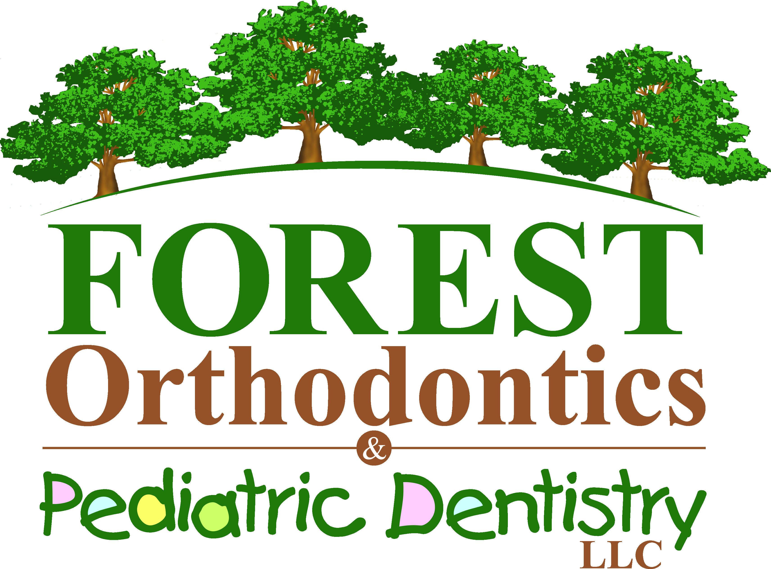

I, Dr. ____________________________ certify that

________________________________ has been in our office today
(patient)
for their routine dental cleaning.

My patient thus qualifies for 100 Bock Bucks to be awarded at

Dr. Bock’s office on submission of this form.

_________________________________
Dentist Signature

_________________________________
Date

*The purpose of our Bock Bucks Reward Program is for our younger patients to take “ownership” in the investment of orthodontic treatment that their parents have provided for them. As an incentive for our patients to have routine dental cleanings with you and also by them displaying good oral hygiene throughout treatment, we will reward them with our Bock Bucks that they may cash in for prizes during orthodontic treatment. Our hope is that this behavioral modification incentive program will help teach accountability for oral health. As always, we recommend that our mutual patients who are in active orthodontic treatment visit you to have 2-3 routine dental cleanings a year to insure healthy gums and teeth.
Thank you for your cooperation in helping our mutual patients achieves the smile that they deserve!

